**MONTGOMERY COLLEGE**

Office of Information Technology – WD& CE InTech Team

Date: August 2012

**PROCEDURE FOR DRIVE SWAPPING IN REMOVALBLE DRIVE CLASSROOMS**

Each of the computer labs in the Gaithersburg Business Training Center, and CF 236 in Takoma Park/Silver Spring have workstations equipped with removal drive technology. This allows the flexibility to prepare the classrooms for multiple courses and configure the rooms quickly for setup changes.

Every instructor **must retrieve drives from the classroom drive cart before each class and install the drives in the system unit**. **At the end of class, the instructor must remove the drives from the system unit and return them to the cart**.

The following is the procedure for removing a drive from the workstation and replacing it with another:

**Items Needed:** *Cabinet housing drives, Removable drive, System unit (or CPU).* ***Note: New procedure does not require keys!***

|  |  |  |
| --- | --- | --- |
| C:\Documents and Settings\pliverpo\Desktop\DSC_6139.jpg | C:\Documents and Settings\pliverpo\Desktop\DSC_6173.jpg | C:\Documents and Settings\pliverpo\Desktop\DSC_6153.jpg |
| Figure 1 | Figure 2 | Figure 3 |

STEPS:

Removable drives are located in the storage cabinets marked with room number and class name.

Go to drawer in cabinet and retrieve portable drive:

The label on the portable drive must match the label located at the top of the monitor that you will be using. For example: Removable drive labeled **TP CF236008** must be used at workstation labeled **TP** **CF236008**

|  |
| --- |
| C:\Documents and Settings\pliverpo\Desktop\DSC_6141.jpg |

Figure 1

Place drive in unit by inserting fingers into the drive lip, as shown, and pull gently toward you making sure that there is no upward motion.

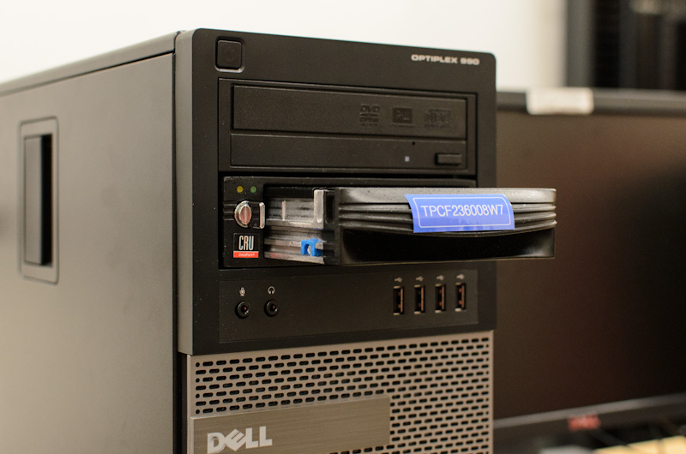

Figure

Insert new portable drive into the drive opening and push firmly until it locks securely in place: Please be careful not to drop the drive!

|  |  |
| --- | --- |
| C:\Documents and Settings\pliverpo\Desktop\DSC_6161.jpg  Figure |  |

Turn key (actually a knob that looks like a key) that is attached to unit from the 12 o’clock position to the 3 o’clock position, this will turn it on; a blue light located in the upper left hand corner above the key knob will come on indicating that the workstation is ready.

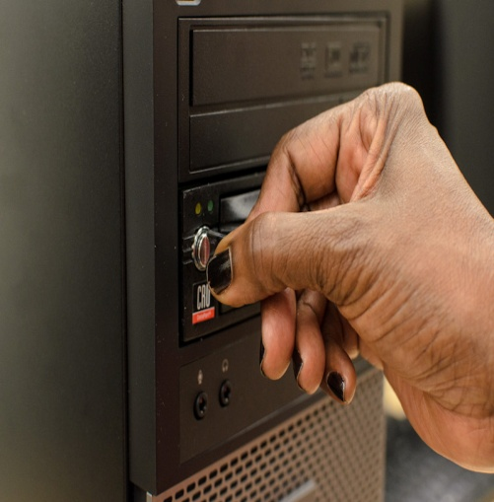

Figure 1

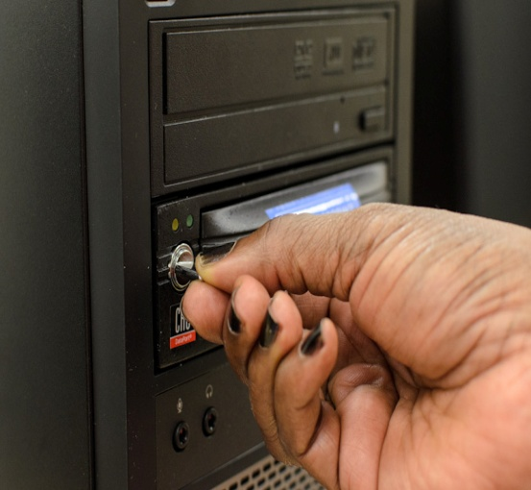

Figure 2

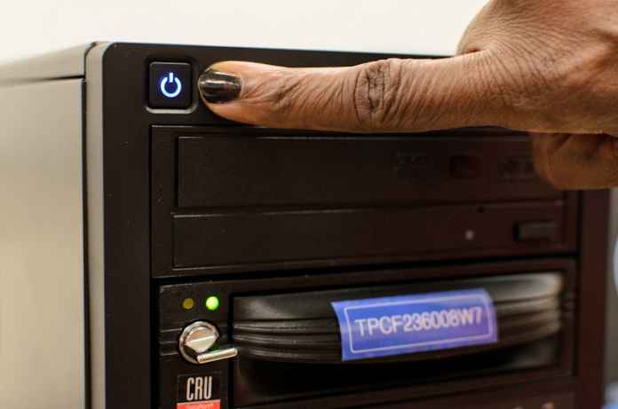

Figure

Steps to remove portable drive when finished using:

1. Power off system
2. Turn attached key (knob) from 3 o’clock position, back to 12 o’clock position
3. Gently remove portable drive from system unit
4. Replace portable drive back in cabinet where it was taken

Each system unit drive can be swapped in about one minute. Allow 15 minutes to swap drives in one classroom of about 18 workstations. Upon completion of the class, the instructor must remove **all** drives from the system units, and **secure** them in the appropriate cabinet drawer.

End of Process